We login to aws account and it shows somethings like this

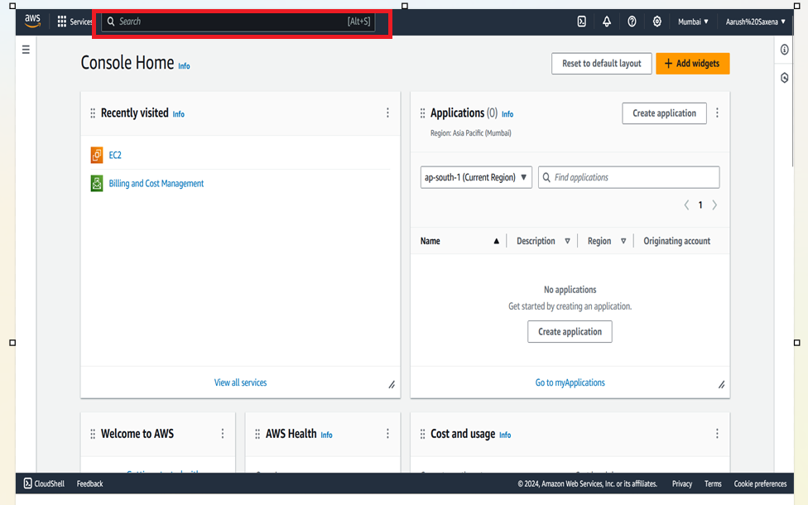

After that click on searchbar and type EC2 click on it

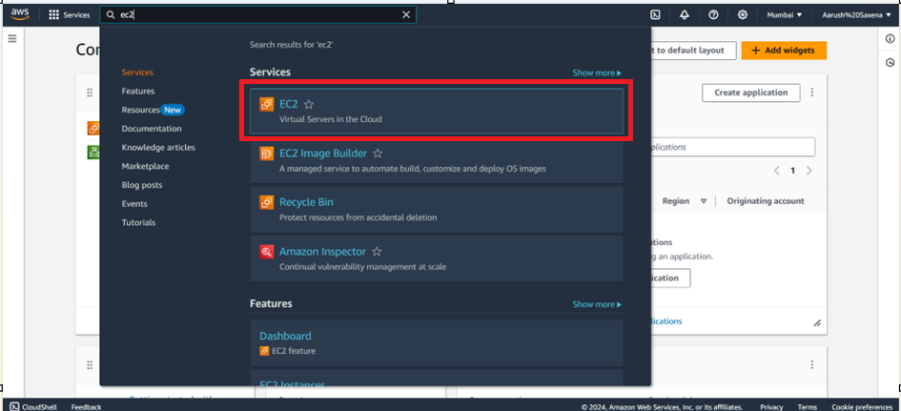

Once you clicked on that a window appeared like this

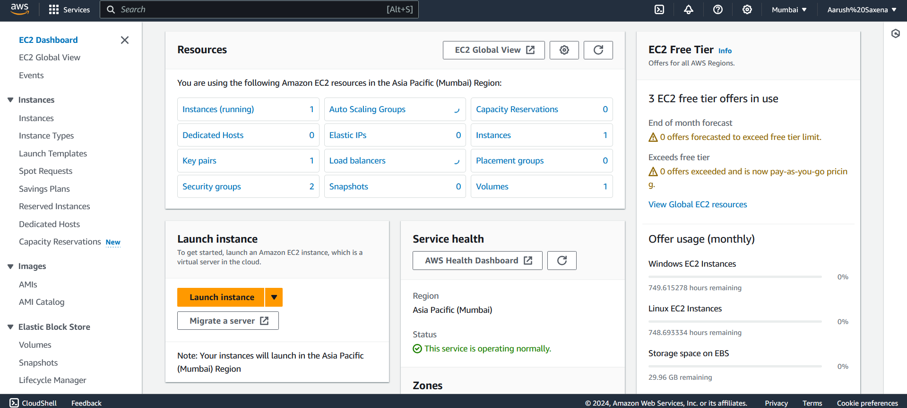

And now click on Instances to make instances

If you have ever made a instance in that region all instances will be shown in this window

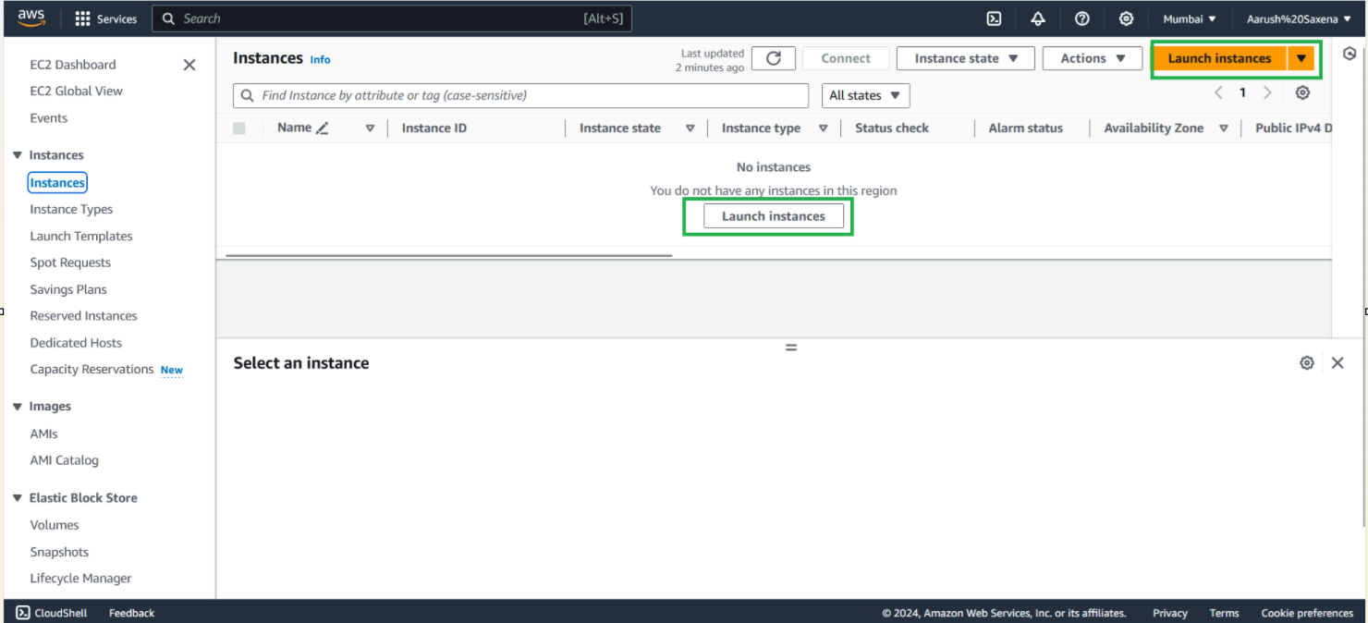

Click on launch instance to make a new instance

As you click on Launch instance a window will appear like this as shown in image given below

And there you can name your instance as your wish and choose your suitable instance’s Operating system to work on it

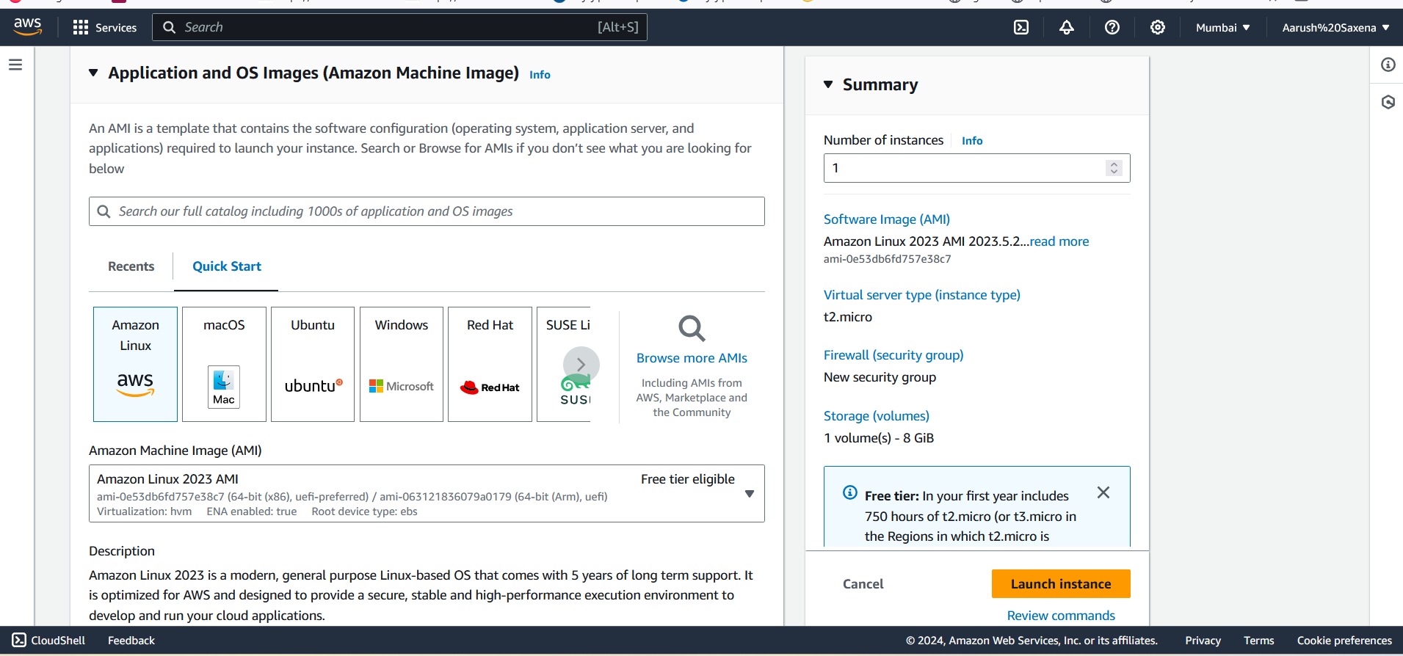

Choose instance type as your wish or as your requirement

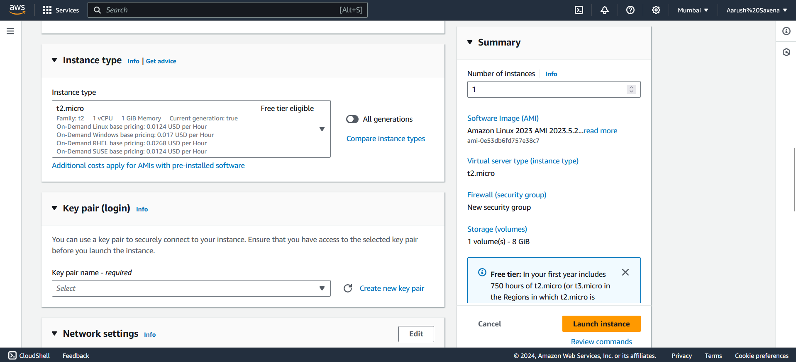

Afte that click on create new key pair and a window will appear as shown in image given below

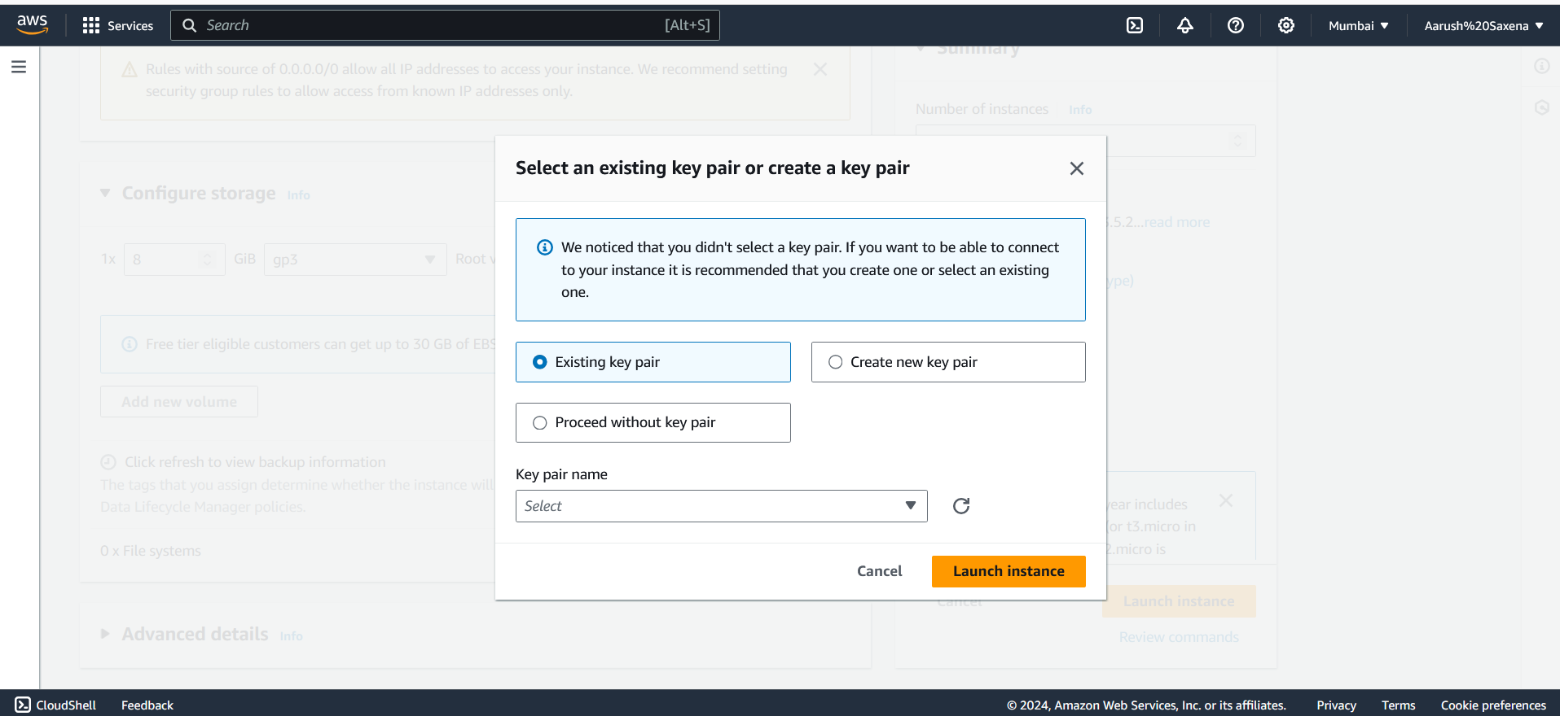

As I have an existing key pair, it’s showing something like this as you don’t have one click on create new key pair and leave other settings to default.

And remember it where you are saving it

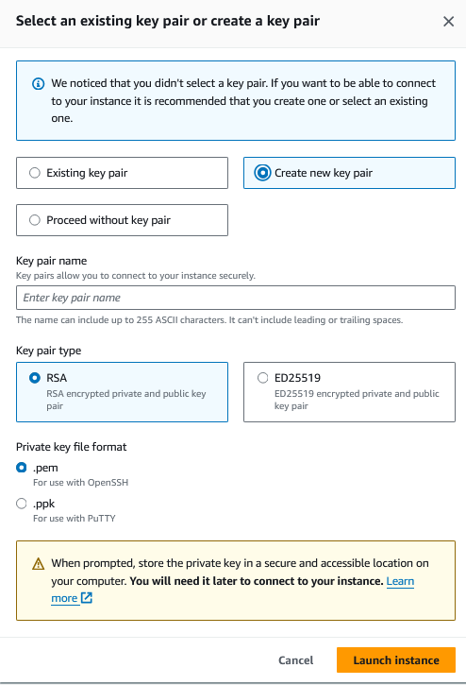

As I save a key pair on my downloads folder it will appear like this

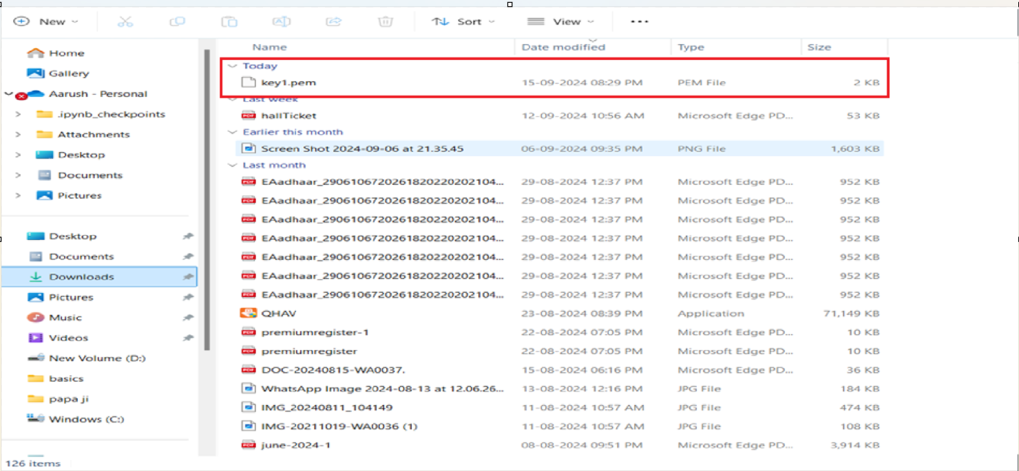

After that remember to allow HTTPS, traffic from the internet option so that you can host your website on internet

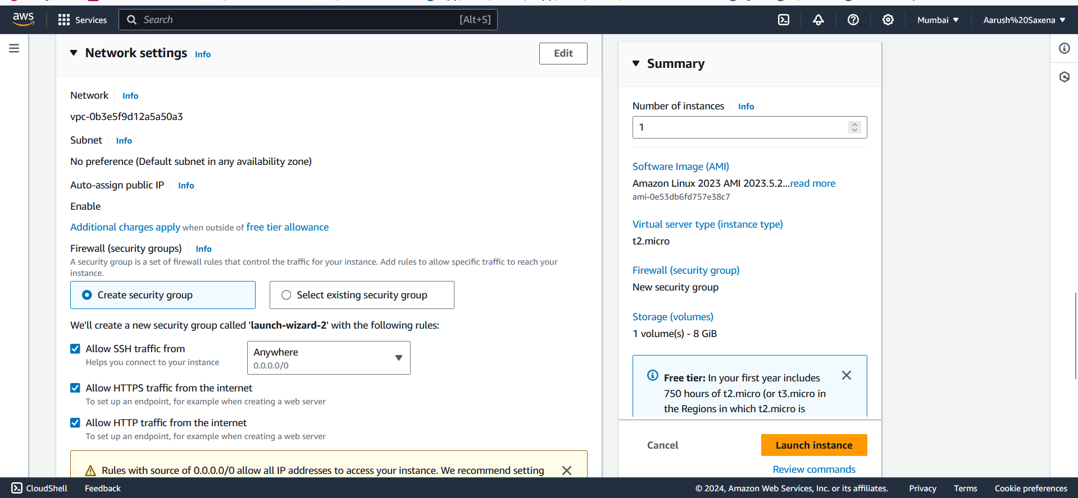

Leave other settings to default settings and Launch instance

Click on edit option of Network settings

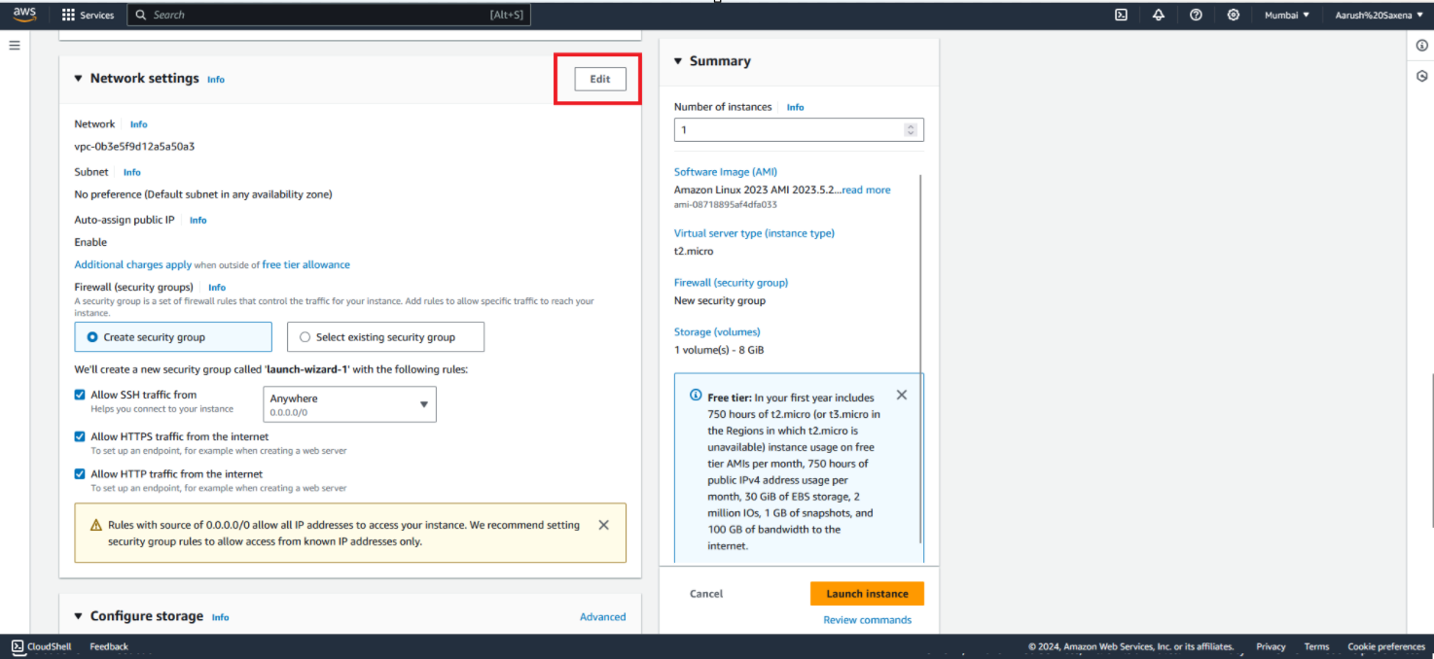

By default it shows options like this image given below

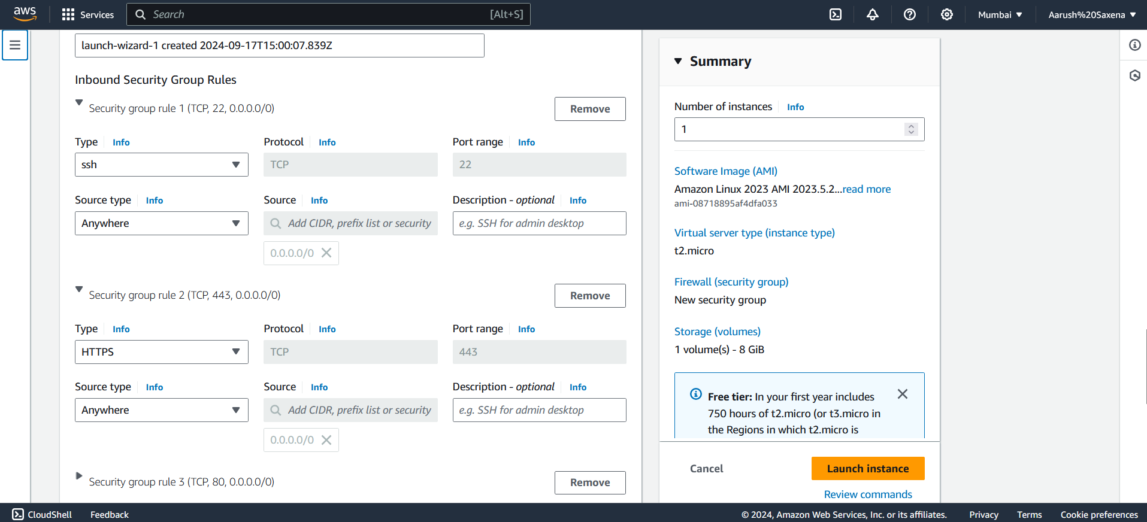

And now we have to change types so that we can allow all traffics

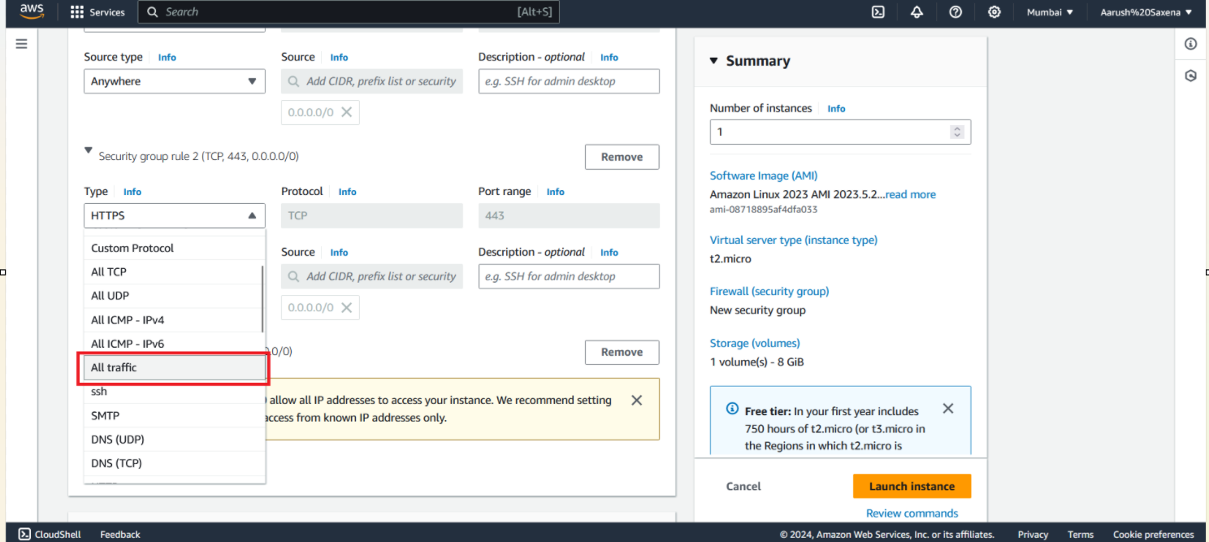

After that click on launch instances

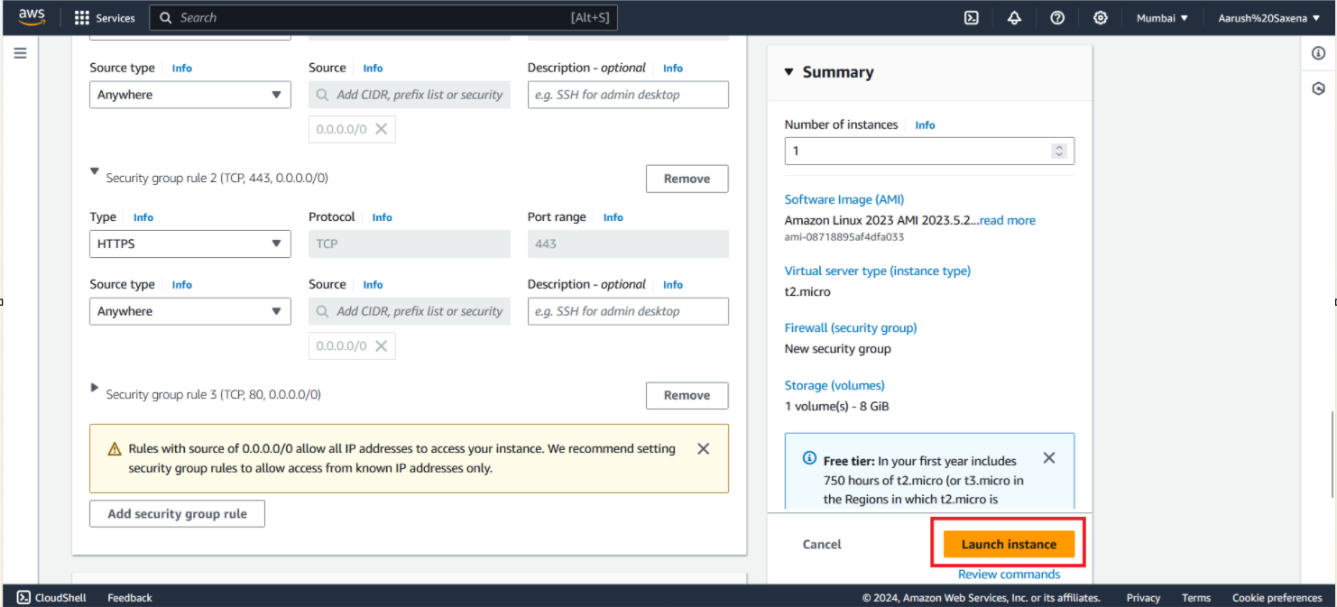

Your instance now has been created

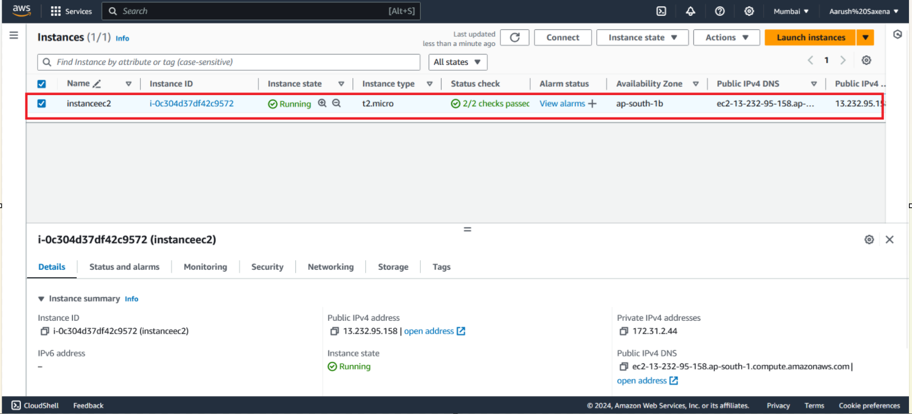

Now you can connect it through cmd, terminal, windows powershell and through aws ec2 connect.

Now select your instance and click on connect button

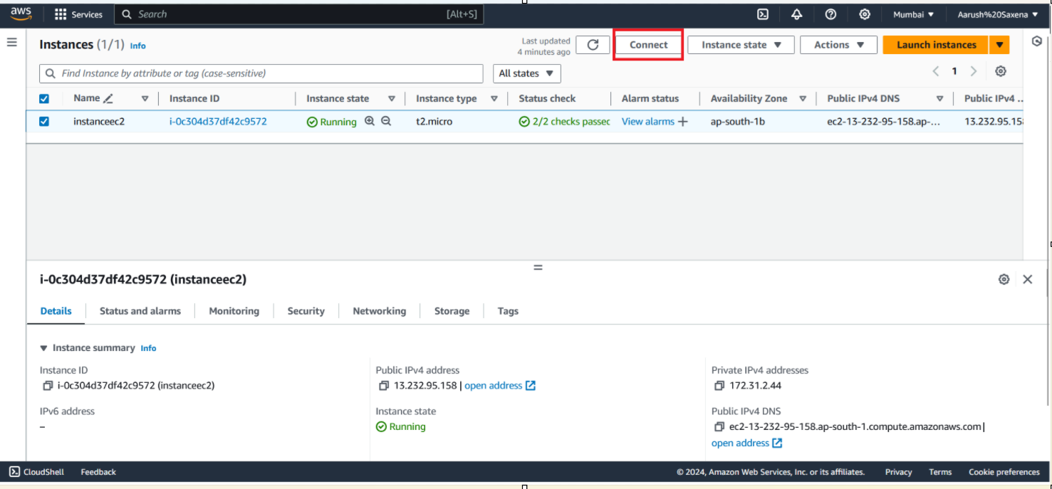

After clicking it shows like this as in the picture given below

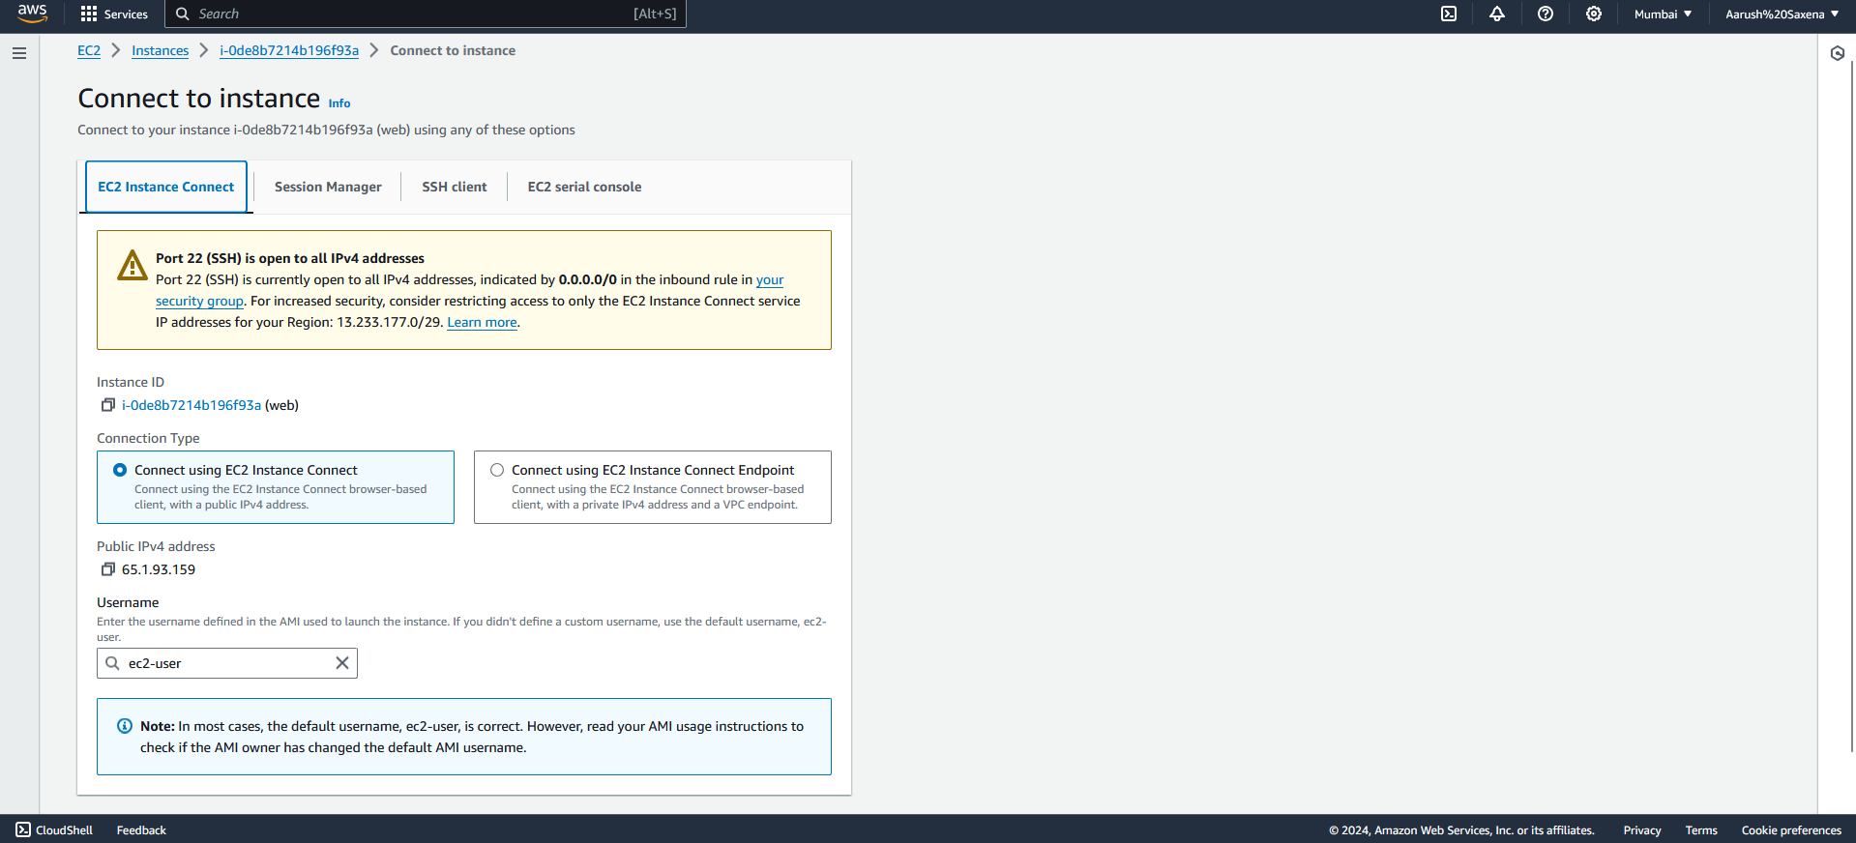

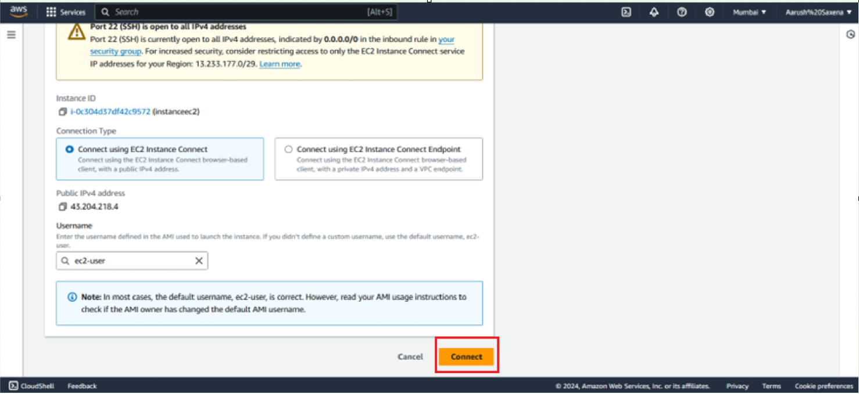

Or we are going to connect it through cmd

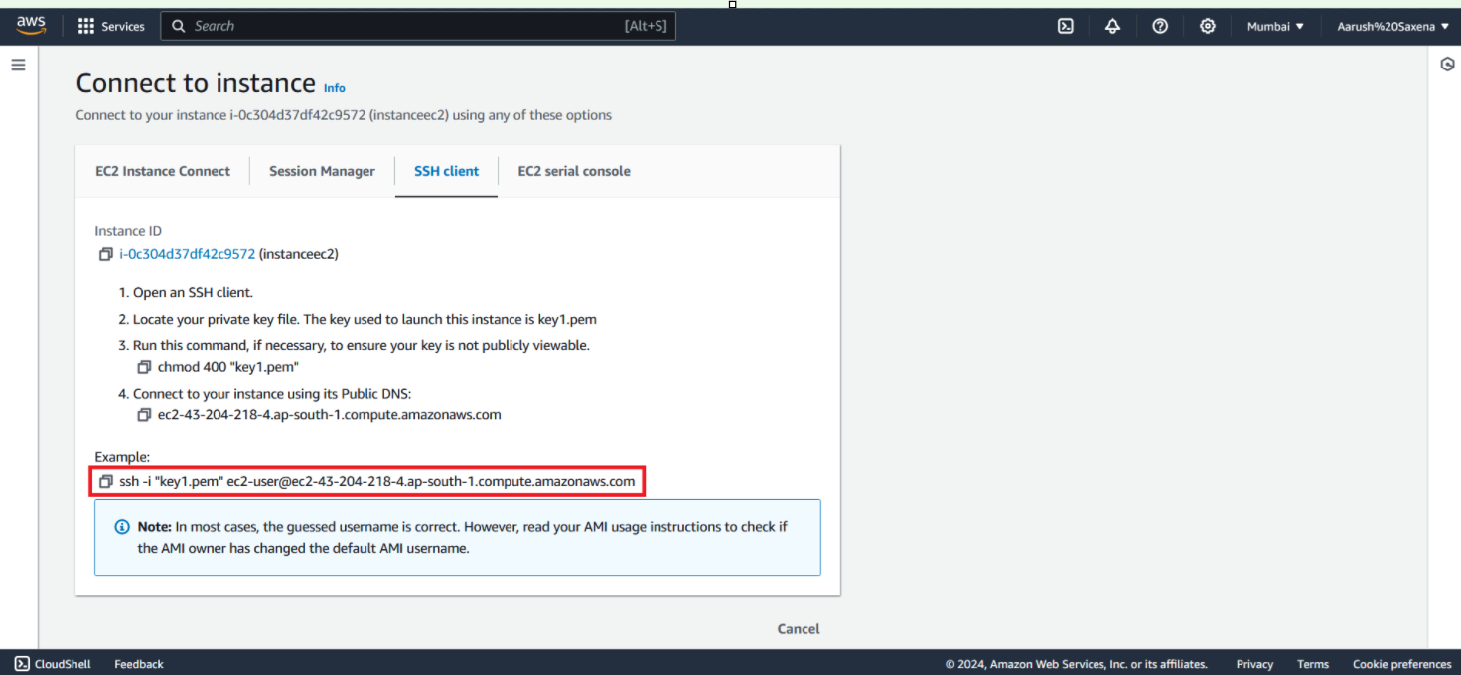

Copy this and paste it to your directory where you download key

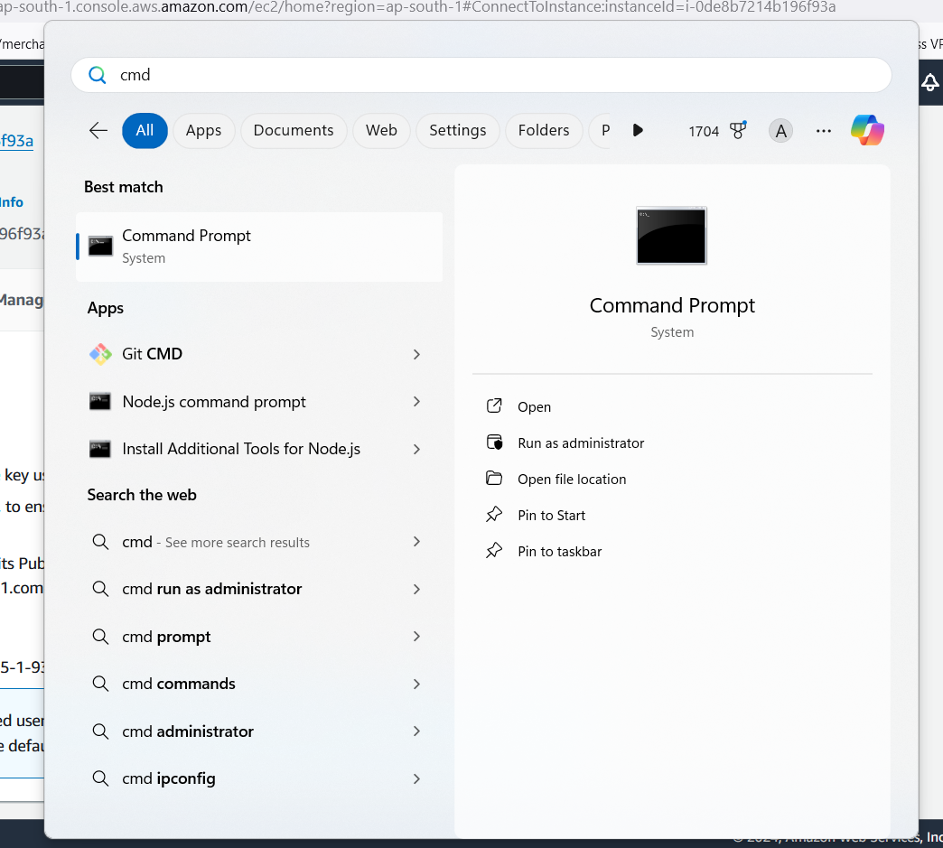

As I downloaded my key in downloads directory go to there

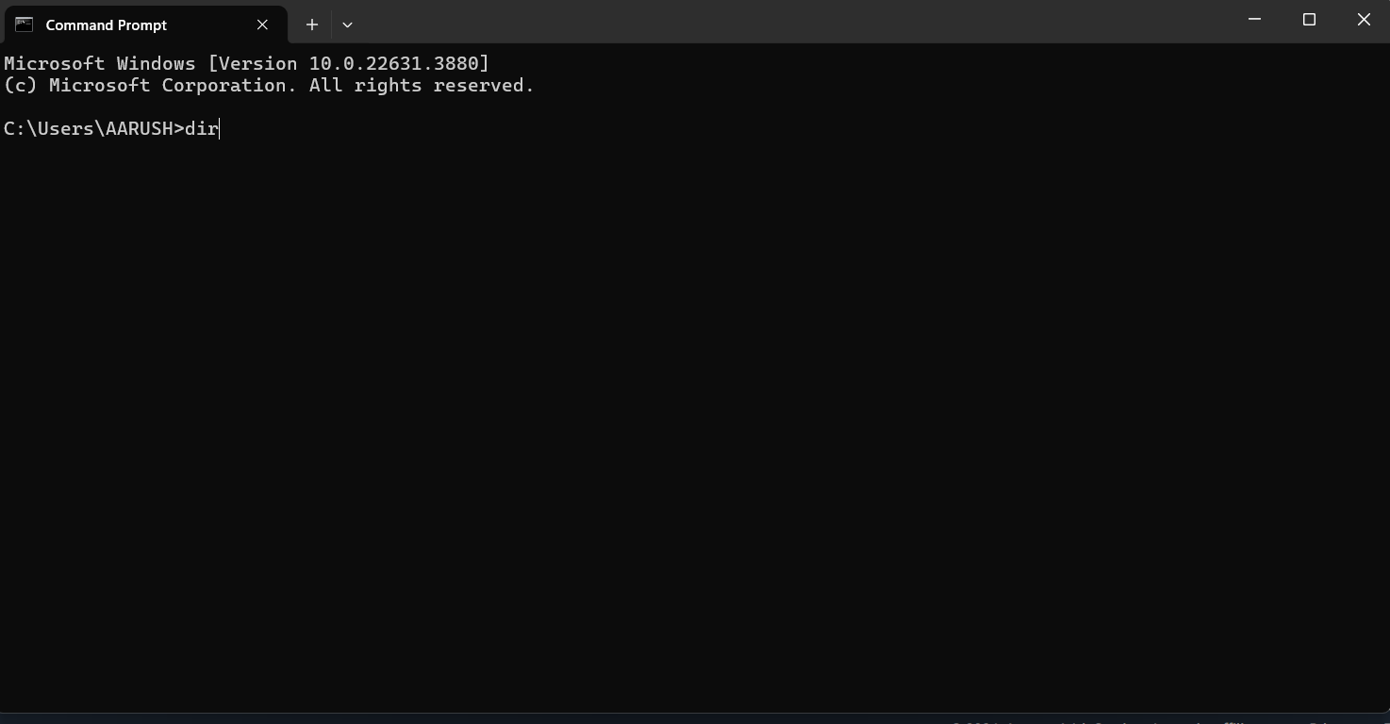

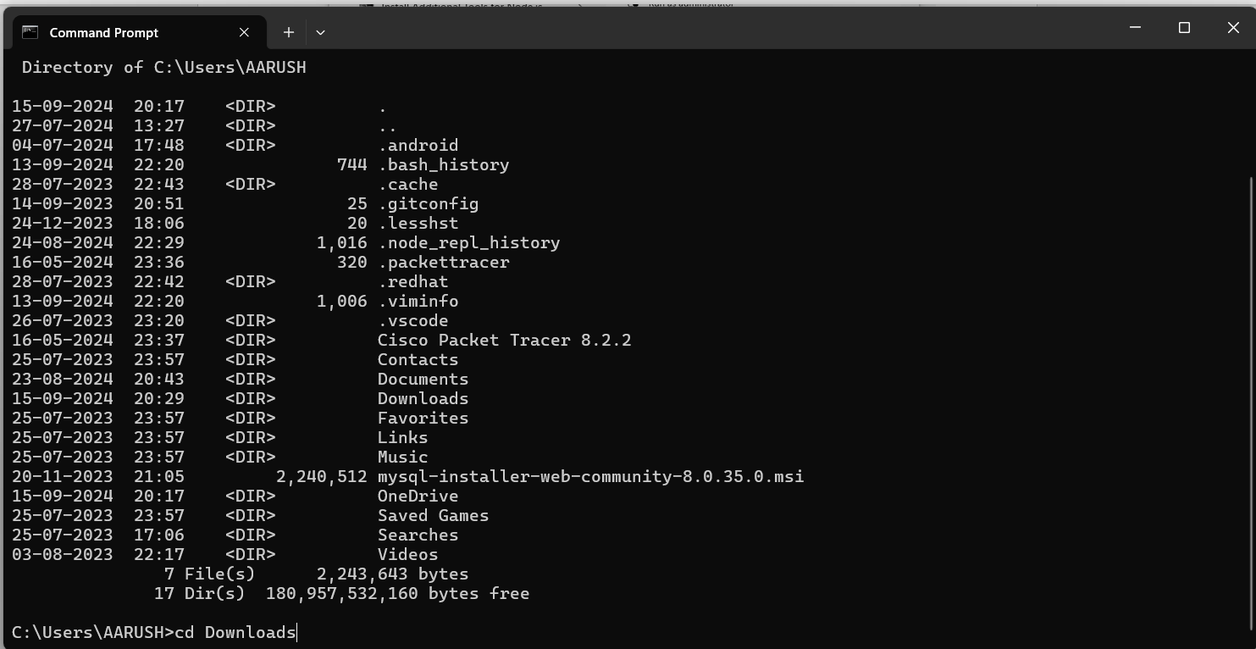

As to confirm that your key actually present there or not type command ls -a

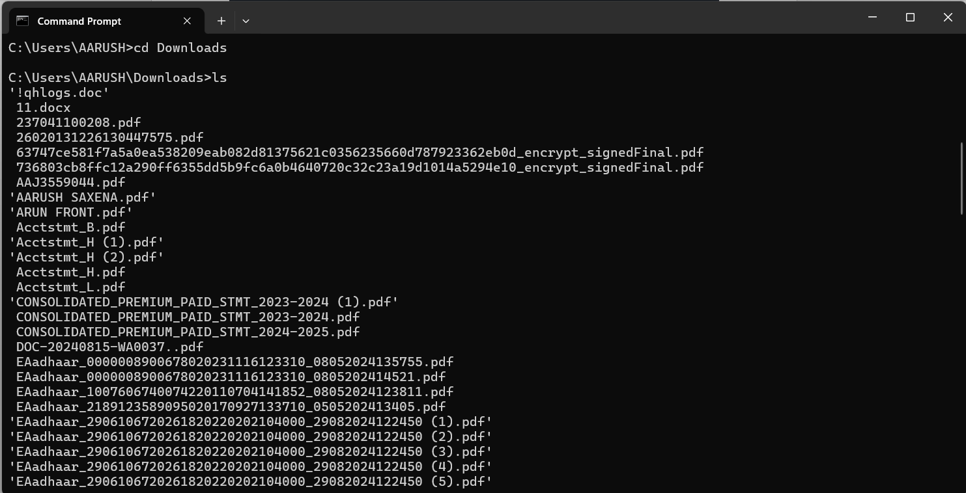

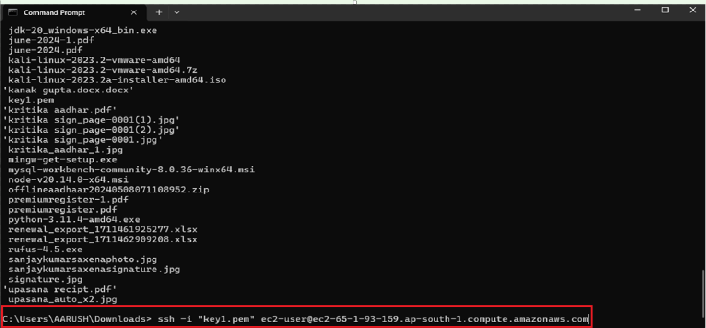

And now paste it code which we have copied it from ssh(aws)

As we entered to it type sudo su to get acess of super user

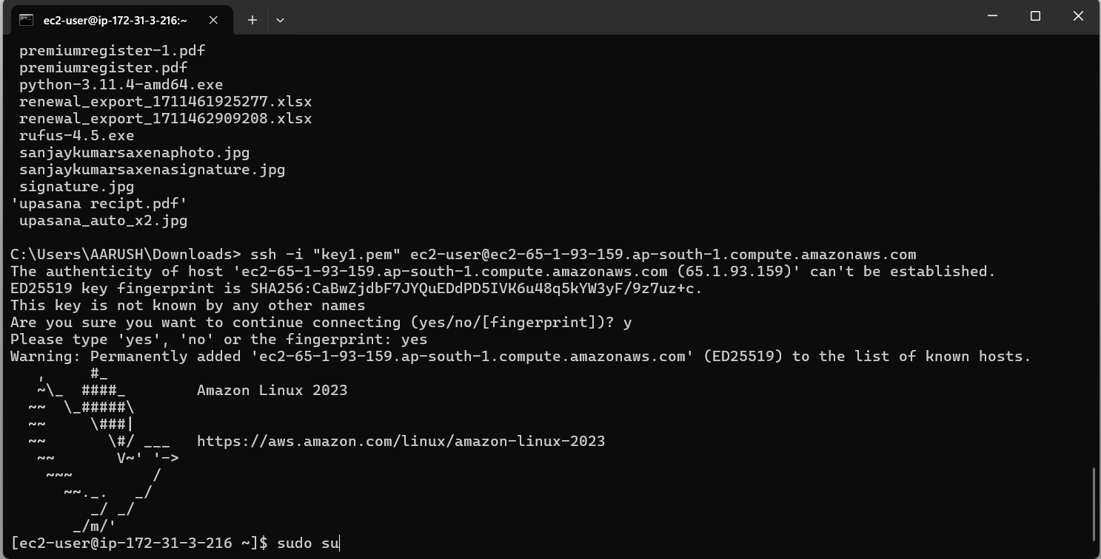

After that type command yum update -y to update it

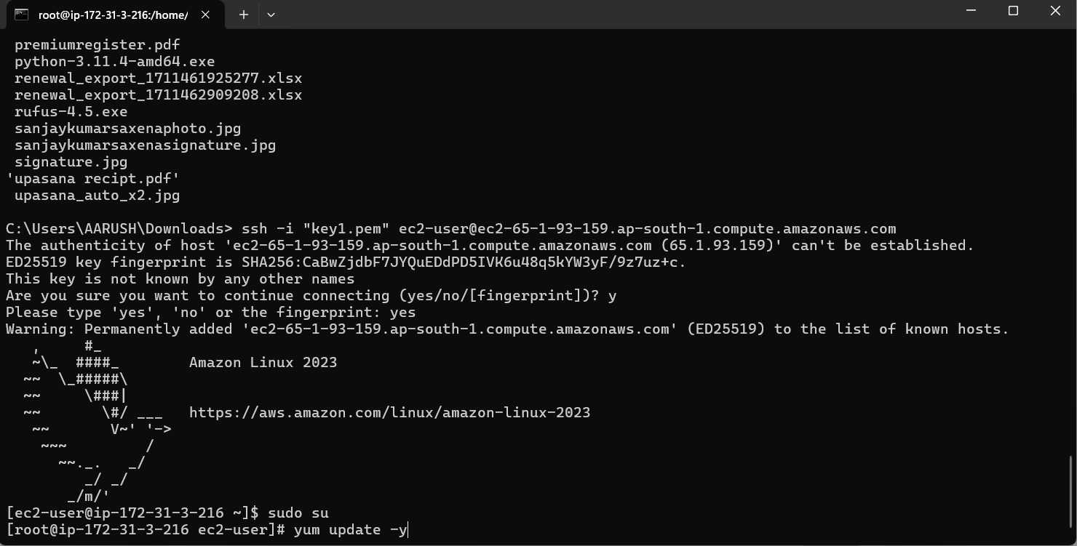

Now you can install nginx or httpd to use the services we are going with httpd

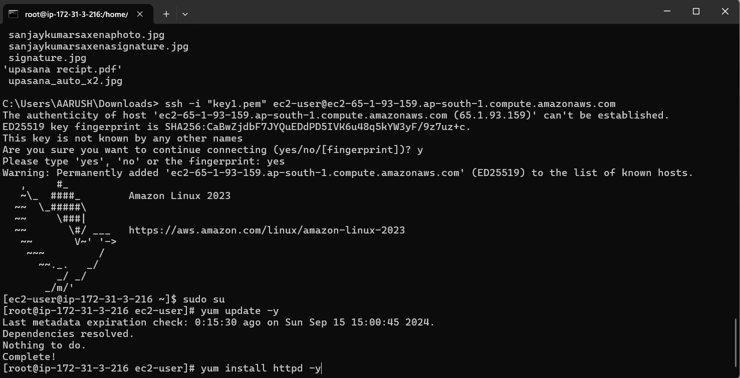

By default when we download httpd it’s services turned off or to check it is open or not type command systemctl status httpd

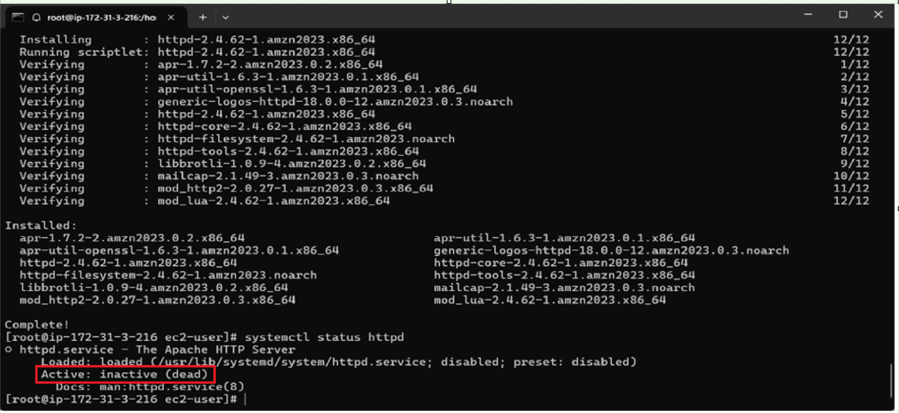

Now to turn on the server we have to type this command systemctl start httpd

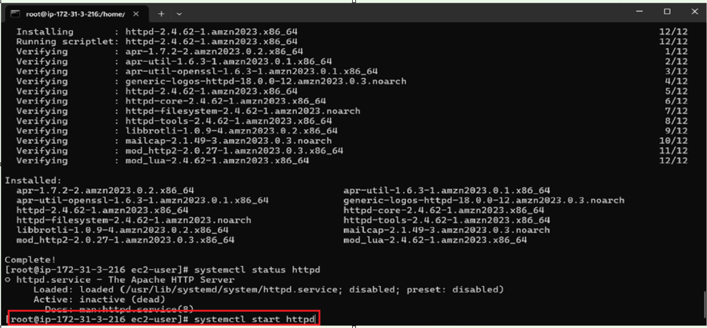

Now you can see that the services has been started

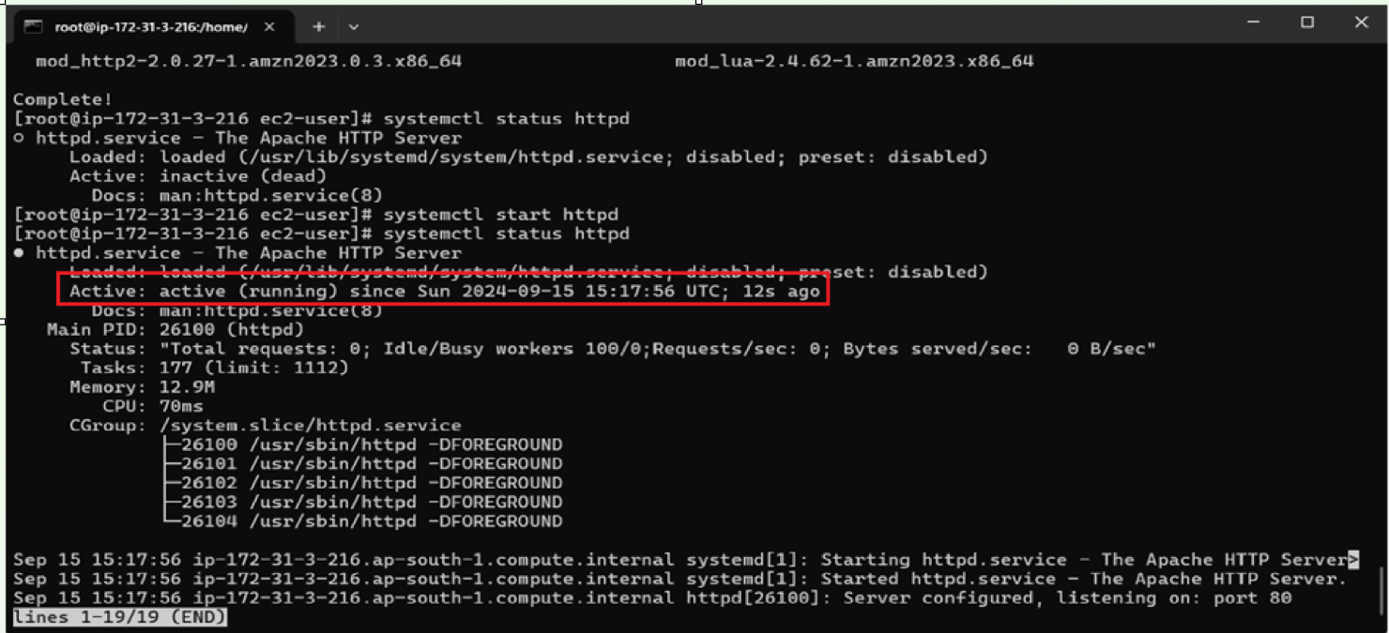

Now we have to go var/www/html

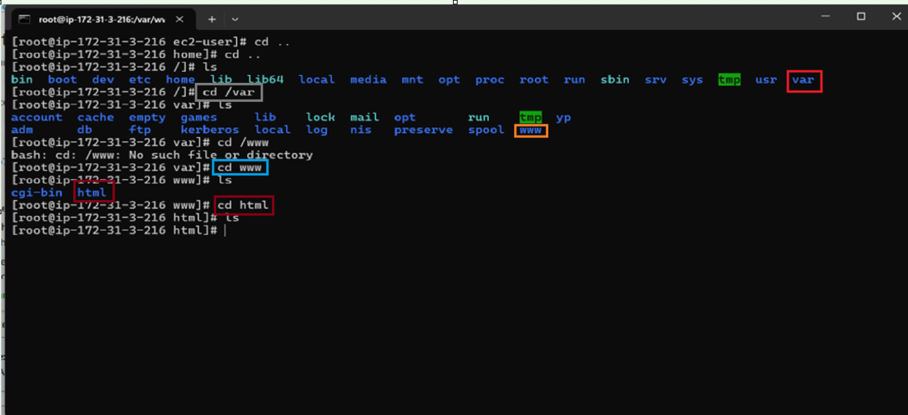

As we can see there Is no file created in this folder so we can make a file in it using vi,vim,cat touch commands and write our own code in it as I have multiple file so I need to install

Two applications:-

1. Putty key gen
2. Win SCP

Putty key gen to generate password for win scp

And winscp helps to move multiple files from local system to remote system

For multiple files to load

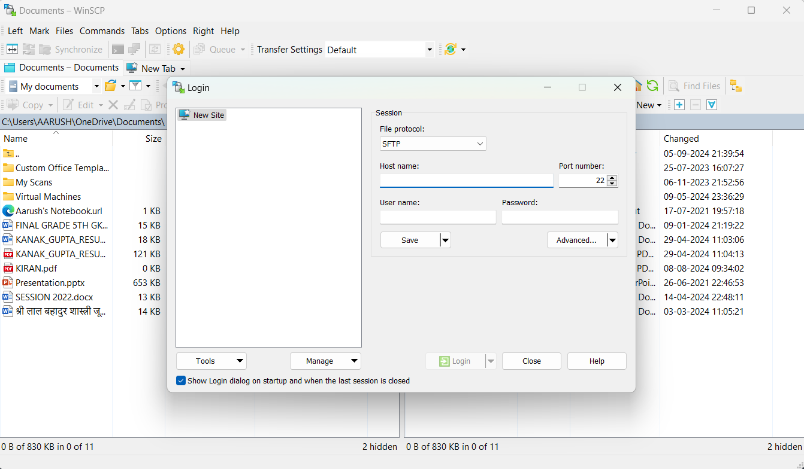

In this host name has to be ip of our instance and username also present there as shown in image given below

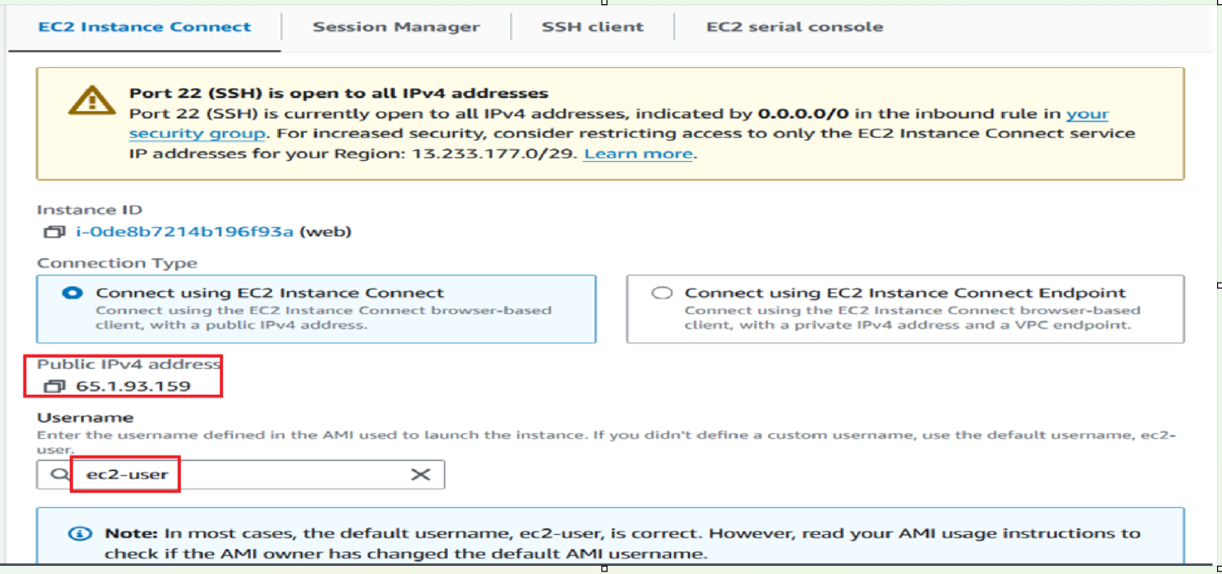

After that we need a password this time we use puttykeygen

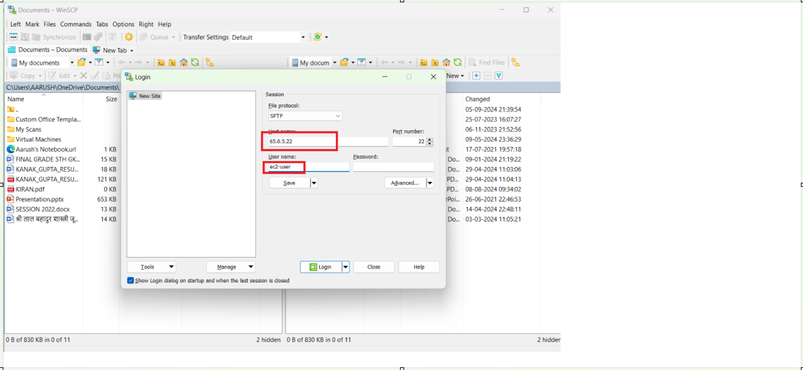

As it accept only putty file than we have to convert it into putt

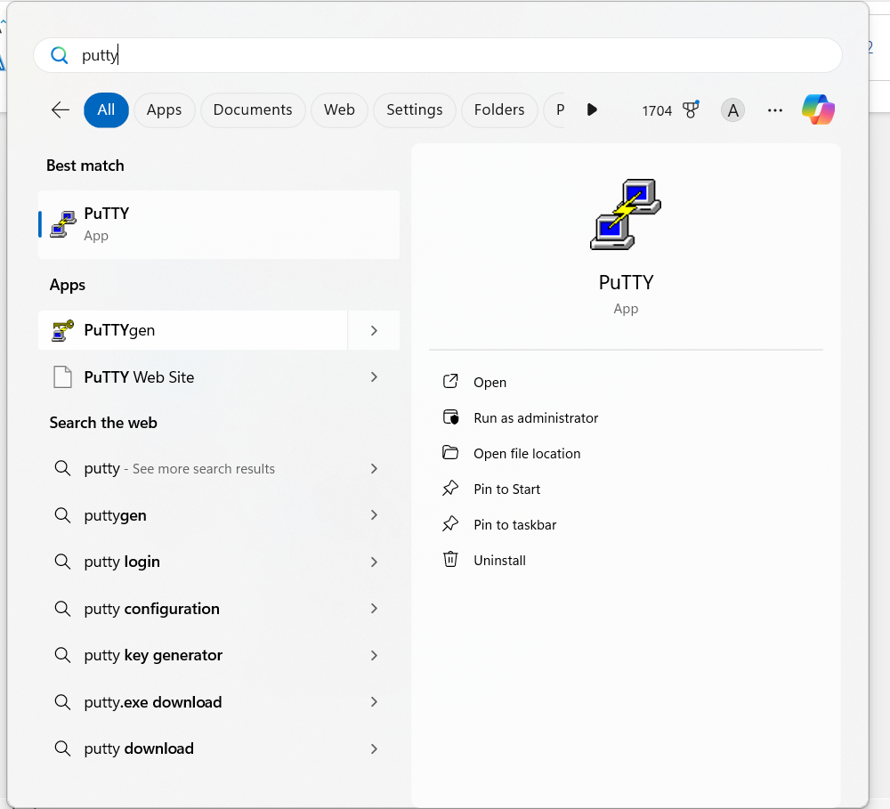

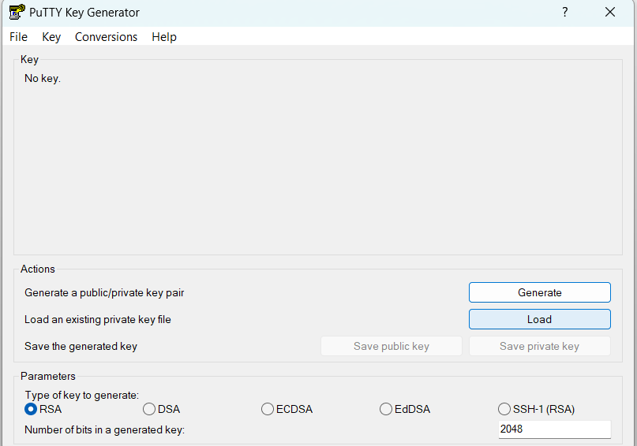

Now we have to load the key file downloaded in downloads folder in our local system and click on Load.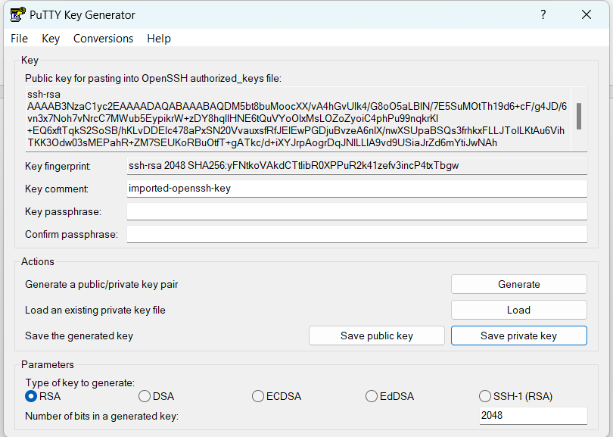

Save this file as Save private key

Then comeback to WinSCP click on Authentication and load file

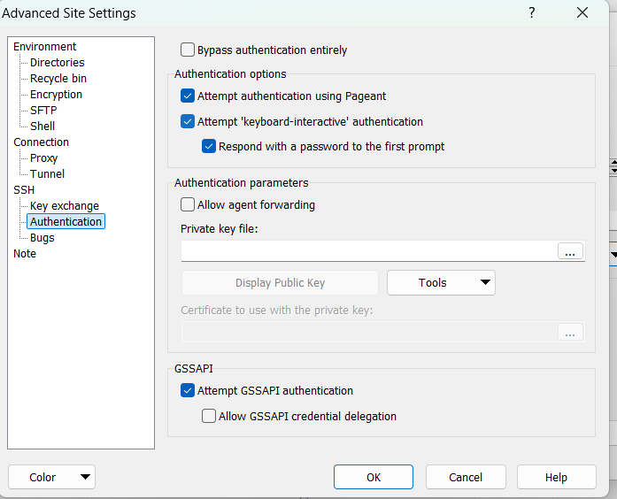

After that click ok and then click login

After than select the files

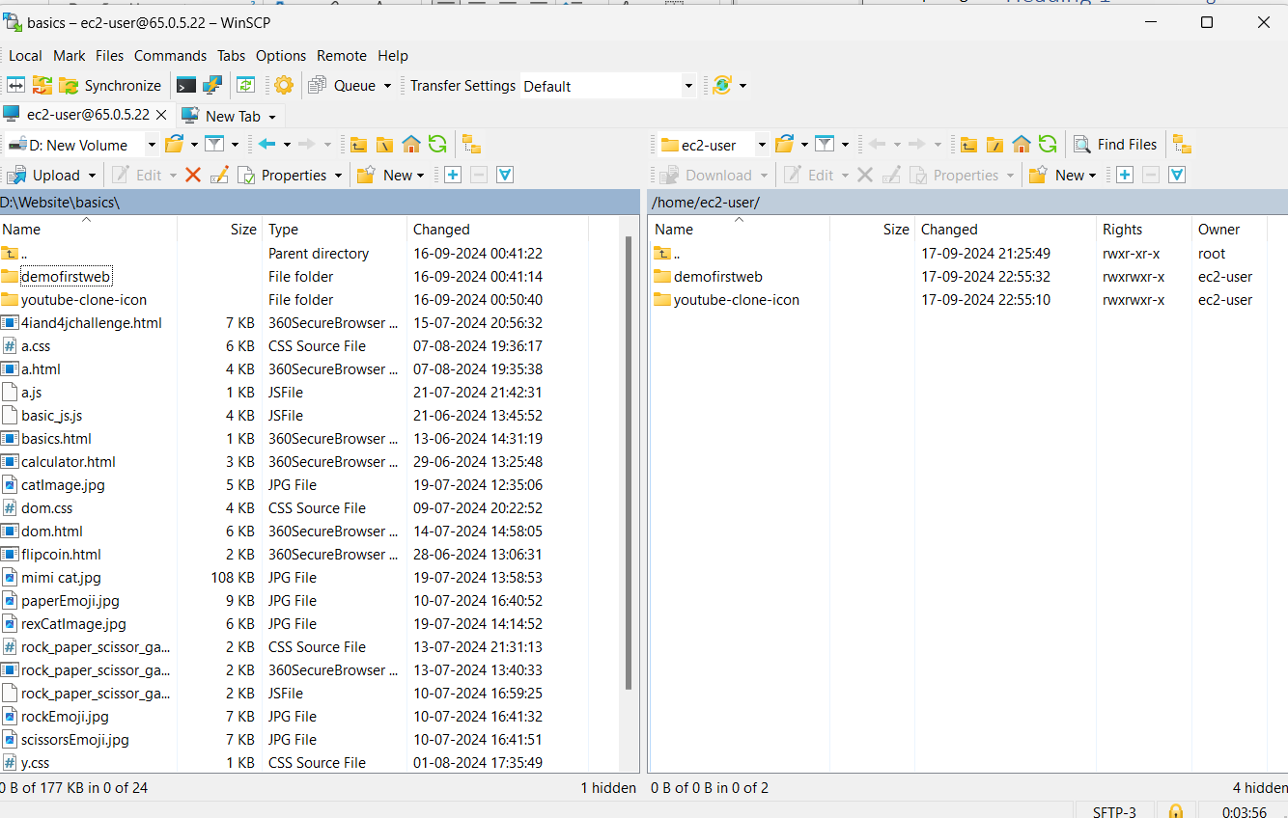

And simple drop and drag it

Now we will copy that files to this location var/www/html

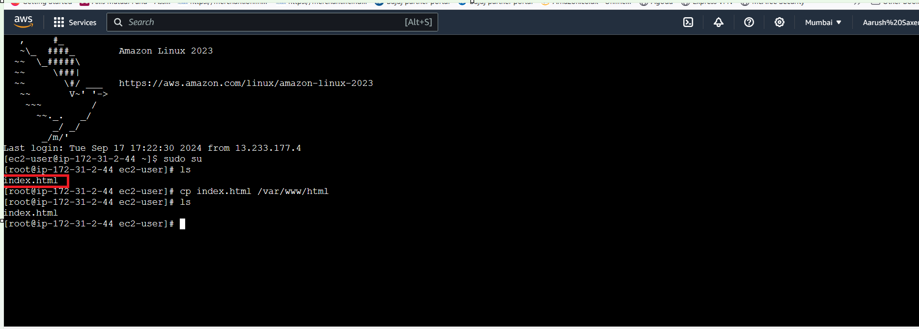

First our files shown in home dir inside it ec2-user and as we type ls command we can see our files

Now with help of cp (copy) command we will copy our files to this location var/www/html

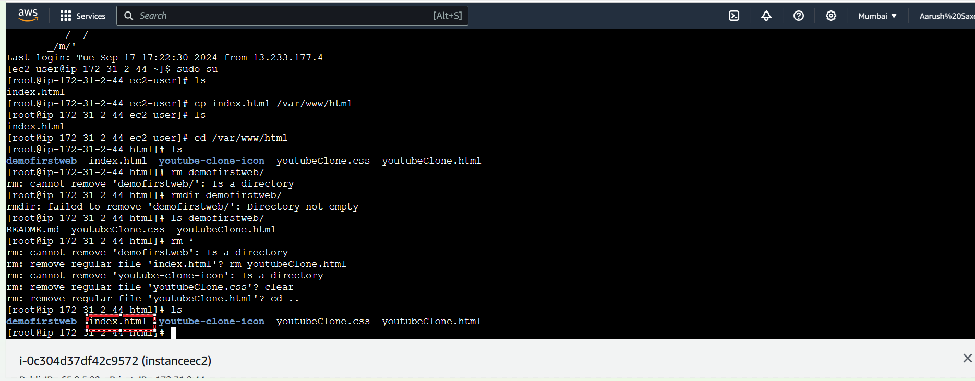

Copy this ip and paste it in any browser

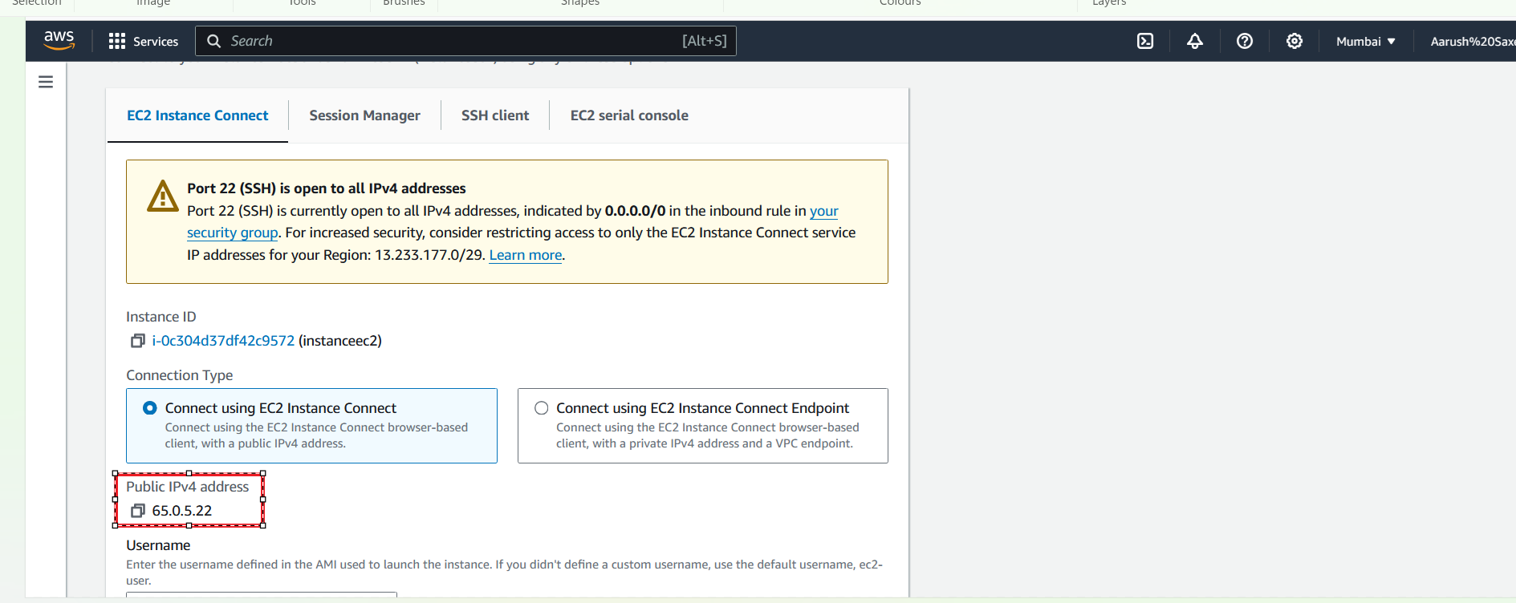

Now you can see your hoisted website

